回复出厂设置，就是删掉所有用户安装的app
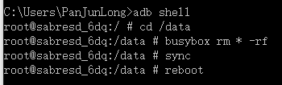

删掉系统自带apk,以读写方式挂载system
adb shell mount -o remount,rw /dev/block/mmcblk0p5 /system
adb shell sync
adb shell mount -o remount,ro /dev/block/mmcblk0p5 /system

